**MOVIE RECOMMENDATION SYSTEM**

project report submitted to the Bharathiar University in the partial fulfillment requirements

for the award of the degree of

**MASTER OF COMPUTER SCIENCE**

Submitted by

**P. MANIKANDAN**

**REG.NO:2132K0136**

Under the Guidance of

**Mrs. P. VISALATCHI, M.Sc., M.Phil.,**

**ASSISTANT PROFESSOR**

**DEPARTMENT OF COMPUTER SCIENCE**



**DEPARTMENT OF COMPUTER SCIENCE**

**SRI VASAVI COLLEGE**

**(Self-Finance Wing)**

**ERODE-638 316**

**(Affiliated to Bharathiar University, Coimbatore)**

**Accredited by NAAC with ‘B’ Grade**

**APRIL - 2023**

CERTIFICATE

**CERTIFICATE**

This is to certify that the project entitled **“MOVIE RECOMMENDATON SYSTEM”** submitted to the **Bharathiar University**, in partial fulfillment of the requirements of the award of the degree of **Master of Computer Science** is a record of original project work done by **P. MANIKANDAN [Reg.No: 2132K0136]** during the period 2022 - 2023 of his study in the **Department of Computer Science** at **Sri Vasavi College (Self-Finance Wing), Erode** under my Supervision and this project has not formed the basis forthe award of any degree/diploma/associate ship/fellowship title to any candidates of any university.

**Head of the Department Signature of the Guide**

**Dean**

Submitted for the Viva-Voice Examination held on____________________

**Internal Examiner External Examiner**

DECLARATION

**DECLARATION**

I hereby declare that this project work entitled **“MOVIE RECOMMENDATION SYSTEM ”** submitted to Bharathiar University in partial fulfillment of the requirement for the award of the Degree of Master of Computer Science is a record of original project work done by me during [**2022-2023]** under the supervision of guidance of **Mrs. P. VISALATCHI, M.Sc., M.Phil.,** Assistant Professor in Computer Science, **Sri Vasavi College (Self Finance Wing), Erode** and this project has not formed the basis for the award of any degree/ diploma/ associate ship/ fellowship or similar title to any candidates of any university.

Signature of the Candidate **P. MANIKANDAN**

**[Reg.No: 2132K0136]**

ACKNOWLEDGEMENT

### ACKNOWLEDGEMENT

If words considered as symbols of approval and tokens of knowledge, lets me use these few words for expressing our gratitude to one and all.

I express my sincere gratitude and thanks to our honorable Secretary **Thiru. G. RAJAARATHINAM, M.Sc.,** Secretary**,** Sri Vasavi College (Self Finance wing), Erode, for permitting us to undertaken our project work.

I am immensely indebted to **Dr. K. ANANDAPADMANABHAN, M.C.A., M.Phil., Ph.D.,** Dean and Head of the Department of Computer Science, Sri Vasavi College (Self Finance Wing), Erode for his valuable and regular Supervision in the course of completion of this project.

I would like to express my since and indebted note of thanks to my Internal Guide **Ms. P. VISALATCHI, M.Sc., M.Phil.,** Assistant Professor, Department of Computer Science, Sri Vasavi College (Self Finance Wing), Erode, for providing a lot of help and excellent guidance.

I thank my beloved parents and friends for their constant support and advice that help me to see a silver lining in every dark cloud. I also express my mindful thanks to my department faculty. Members for their suggestion to complete my project in time.

SYNOPSIS

**SYNOPSIS**

The Project entitled **“MOVIE RECOMMENDATION SYSTEM”** is developed by using HTML and JAVA SCRIPT as Front-End PYTHON as Back-End. The main purpose of this project is Movie Recommendation system trained dataset using machine learning concepts. The project provides most of the basic functionality requires for Recommendation the movie names and releasing date. This Web site using to what is reliable movie list show on you. You can use my web site comparable list show on my site that help to don’t waste our time. If you put your favorite move name on here that machine learning algorithm, give suggestion list.

CONTENTS

**CONTENT**

|  |  |  |
| --- | --- | --- |
| **CHAPTER NO.** | **TITLE** | **PAGE.NO.** |
| 1. | **INTRODUCTION** | 1 |
|  | 1.1ABOUT THE PROJECT | 1 |
| 2. | **SYSTEM STUDY ANALYSIS** | 2 |
|  | 2.1 PROBLEM DEFINTION | 2 |
|  | 2.2 EXISTING SYSTEM | 2 |
|  | 2.3 DRAWBACKS OF EXISTING SYSTEM | 2 |
|  | 2.4 PROPOSED SYSTEM | 2 |
|  | 2.5 ADVANTAGES OF PROPOSED SYSTEM | 3 |
|  | 2.6 FEASIBILITY STUDY | 3 |
| 3. | **SYSTEM REQUIREMENTS** | 5 |
|  | 3.1 HARDWARE REQUIREMENTS | 5 |
|  | 3.2 SOFTWARE REQUIREMENTS | 5 |
|  | 3.3 SOFTWARE DESCRIPTION | 6 |
| 4. | **SYSTEM DESIGN AND DEVELOPMENT** | 13 |
|  | 4.1 DATA FLOW DIAGRAM | 13 |
|  | 4.2 INPUT DESIGN | 14 |
|  | 4.3 OUTPUT DESIGN | 14 |
|  | 4.4 DATABASE DESIGN | 15 |
|  | 4.5 SYSTEM REQUIREMENTS | 15 |
|  | 4.6 MODULE DESCRIPTION | 16 |
| 5. | **SYSTEM TESTING AND IMPLEMENTATION** | 17 |
|  | 5.1 SYSTEM TESTING | 17 |
| 6. | **CONCLUSION** | 18 |
| 7. | **SCOPE FOR FUTURE STUDY** | 19 |
| 8. | **BIBLIOGRAPHY** | 21 |
|  | 1. SOUCE CODE | 22 |
|  | 1. SCREEN SHOTS | 29 |

INTRODUCTION

**1. INTRODUCTION**

**1.1 ABOUT THE PROJECT**

Movie recommendation system website using to view recommended movie list name and movie release date. This project is developed in html, CSS, java script and python. That recommended system helps to save time and searching comfortable. The project provides most of the basic functionality required for movie recommendation system. You can use this website to recommending following movie name list and to know information about movie rating.

FRONT END : HTML, JAVA SCRIPT.

BACK END : PYTHON FLASK, CSV DATASET.

SYSTEM STUDY AND

ANALYSIS

**2. SYSTEM STUDY AND ANALYSIS**

**2.1 PROBLEM DEFINITION**

The existing system was carried out manually. The drawbacks of the existing system are taken into consideration. The website should provide facilitate to Movie recommendation analysis and flask use to display on website, rating and content based. There are lot of difficulties in the manual recommending product. The time required to process of recommendation system is very high and give an accurate value.

**2.2 EXISTING SYSTEM**

In present days, Most of the people do not know the basic information of product and the information about the material required for the movie list are not known. They are more likely to be deceived by this ignorance. Our website definitely should be the solution for this type of the problems.

**2.3 DRAWBACKS OF EXISTING SYSTEM**

* Taking high time duration for recommendation
* Non predictable cost
* Bargaining problem
* Direct Access will incur travel expenses
* Not being available on the days it can cause us stress

Due to these drawbacks in the existing system, there is a need for computerization.

**2.4 PROPOSED SYSTEM**

The existing system is a manual process. The action is regarding for recommending for the product is on manually. It is computerized using HTML, CSS, Java Script (FRONT END) and PYTHON FLASK, CSV DATASETS (BACK END) To overcome the drawbacks of the existing system, the proposed system has been evolved. This recommendation systems aims to reduce the taking time duration and reduce cost for recommending product. The system provides with the best user interface. The proposed system has two major benefits. Once the existing system is automated all the drawbacks of the present system can be overcome. Many modifications can be made to make the atmosphere and extractions of data for generating a variety of reports are the factors, which form the basis of development of the proposed system.

**2.5 ADVANTAGES OF PROPOSED SYSTEM**

* A modern approach of recommending product(movie).
* It is trouble-free to use.
* It is a relatively fast approach to get good quality of name list.
* Is highly reliable, approximate result from user.
* Best user Interface.
* To satisfy all user requirements.
* The system is very flexible.

**2.6 FEASIBILITY STUDY**

The feasibility of the project is analyzed in this phase and business proposal is put forth with a very general plan for the projects and some cost estimates. This is to ensure that the proposed system is not a burden to the company. A feasibility analysis is to test of the system proposal according to its wok ability, impact on the organization and ability to meet user needs.

Three key considerations involved in the feasibility analysis are

* Economic feasibility.
* Operational feasibility.
* Technical feasibility.

**ECONOMICAL FEASIBILITY**

This study is carried out to check the economic impact that the system will have on the organization. The amount of fund that the company can pour into the research and development of the system is limited. The expenditures must be justified. Thus, the developed system as wheel within the budget and this was achieved because most of the technologies used are freely available. Only the customized products had to be purchased. This project is economically feasible.

**OPERATIONAL FEASIBILITY**

Operational feasibility is necessary as it ensures the project developed is a successful one. Test have been carried out to ensure the operational feasibility of the system. The proposed system works efficiently and displays the information very quickly. The various aspects of the operational feasibility are used to measure the urgency and the acceptability of the solution that has been proposed. This project is operationally feasible.

**TECHNICAL FEASIBILITY**

This study is carried out to check the technical feasibility, that is the technical requirements of the system. Any system developed must not have a high demand on the available technical resources. This will lead to high demands on the available technical resources. This will lead to high demand being placed on the client.

SYSTEM REQUIREMENTS

**3. SYSTEM SPECIFICATION**

**3.1 HARDWARE CONFIGURATION**

PROCESSOR : AMD PRO A4-4350B 2.5Ghz

RAM : 4 GB

HARD DISK : 500 GB

MONITOR : Generic PnP Monitor

KEYBOARD : Standard PS/2 Keyboard

MOUSE : Synaptic PS/2 Port Touchpad

**3.2 SOFTWARE SPECIFICATION**

OPERATING SYSTEM : Windows 10

ENVIRONMENT : Python 3.11.2

IDE : Visual Studio Code

FRONT END : HTML, JAVASCRIPT

BACK END : PYTHON (FLASK)

**3.3 SOFTWARE DESCRPTION**

**FRONTEND: HTML, CSS, JAVASCRIPT**

Hypertext Markup Language (HTML), Cascading Style Sheets (CSS), and JavaScript are the languages that run the web. They’re very closely related, but they’re also designed for very specific tasks. Understanding how they interact will go a long way towards becoming a web developer. We’ll be expanding on this throughout the tutorial, but the gist of it is:

* HTML is for adding meaning to raw content by marking it up.
* CSS is for formatting that marked up content.
* JavaScript is for making that content and formatting interactive.

Think of HTML as the abstract text and images behind a web page, CSS as the page that actually gets displayed, and JavaScript as the behaviors that can manipulate both HTML and CSS.

**HTML (Hypertext Markup Language):**

HTML stands for Hypertext Markup Language, and it is the most widely used language to write Web Pages. Hypertext refers to the way in which Web pages (HTML documents) are linked together. Thus, the link available on a webpage is called Hypertext. As its name suggests, HTML is a Markup Language which means you use HTML to simply "mark-up" a text document with tags that tell a Web browser how to structure it to display. Originally, HTML was developed with the intent of defining the structure of documents like headings, paragraphs, lists, and so forth to facilitate the sharing of scientific information between researchers. Now, HTML is being widely used to format web pages with the help of different tags available in HTML language.

**JAVA SCRIPT:**

JavaScript is a dynamic computer programming language. It is lightweight and most commonly used as a part of web pages, whose implementations allow client-side script to interact with the user and make dynamic pages. It is an interpreted programming language with object-oriented capabilities.

JavaScript was first known as Live Script, but Netscape changed its name to JavaScript, possibly because of the excitement being generated by Java. JavaScript made its first appearance in Netscape 2.0 in 1995 with the name Live Script. The general-purpose core of the language has been embedded in Netscape, Internet Explorer, and other web browsers.

**ADVANTAGES OF JAVASCRIPT**

The merits of using JavaScript are −

* **Less server interaction**− You can validate user input before sending the page off to the server. This saves server traffic, which means less load on your server.
* **Immediate feedback to the visitors**− They don't have to wait for a page reload to see if they have forgotten to enter something.
* **Increased interactivity**− You can create interfaces that react when the user hovers over them with a mouse or activates them via the keyboard.
* **Richer interfaces**− You can use JavaScript to include such items as drag-and-drop components and sliders to give a Rich Interface to your site visitors.

**FEATURES OF VISUAL STUDIO CODE**

Visual Studio Code combines the simplicity of a source code editor with powerful developer tooling, like IntelliSense code completion and debugging. First and foremost, it is an editor that gets out of your way. The delightfully frictionless edit-build-debug cycle means less time fiddling with your environment, and more time executing on your ideas.

**VISUAL STUDIO CODE**

Visual Studio Code is a code editor in layman’s terms. Visual Studio Code is “a free-editor that helps the programmer write code, helps in debugging and corrects the code using the intelli-sense method ”. In normal terms, it facilitates users to write the code in an easy manner. Many people say that it is half of an IDE and an editor, but the decision is up to to the coders. Any program/software that we see or use works on the code that runs in the background. Traditionally coding was used to do in the traditional editors or even in the basic editors like notepad! These editors used to provide basic support to the coders.

**FEATURES:**

1. **Support for multiple programming languages:**Supports multiple programming languages. So earlier, programmers needed Web-Support: a different editor for different languages, but it has built-in multi-language support. This also means it easily detects if there’s any fault or cross-language reference, it’ll be able to detect it easily.
2. **Intelli-Sense:**It can detect if any snippet of code is left incomplete. Also, common variable syntaxes and variable declarations are made automatically. Ex: If a certain variable is being used in the program and the user has forgotten to declare, intelli-sense will declare it for the user.
3. **Cross-Platform Support:**Traditionally, editors used to support either [Windows or Linux or Mac Systems](https://www.educba.com/linux-vs-mac-vs-windows/). But Visual Studio Code is cross-platform. So it can work on all three platforms. Also, the code works on all three platforms; else, the open-source and proprietary software codes used to be different.
4. **Extensions and Support:**Usually supports all the programming languages but, if the user/programmer wants to use the programming language which is not supported then, he can download the extension and use it. And performance-wise, the extension doesn’t slow down the editor as it rums as a different process.
5. **Repository:**With the ever-increasing demand for the code, secure and timely storage is equally important. It is [connected with Git](https://www.educba.com/git-alternatives/) or can be connected with any other repository for pulling or saving the instances.
6. **Web-Support:**Comes with built-in support for Web applications. So web applications can be built and supported in VSC.
7. **Hierarchy Structure:**The code files are located in files and folders. The required code files also have some files, which may be required for other complex projects. These files can be deleted as per convenience.
8. **Improving Code:**Some code snippets can be declared a bit differently, which might help the user in the code. This function prompts the user, wherever necessary, to change it to the suggested option.

**There are many advantages over any other IDE:**

1. Cross-platform support:

* + Windows
  + Linux
  + Mac

2. Light-weight

3. Robust Architecture

4. Intelli-Sense

5. Freeware: Free of Cost- probably the best feature of all for all the programmers out there, even more for the organizations.

6. Many users will use it or might have used it for desktop applications only, but it also provides great tool support for Web Technologies like; HTML, CSS, JSON.

**BACK END: PYTHON FLASK**

Python is an interpreted, object-oriented, high-level programming language with dynamic semantics. Its high-level built-in data structures, combined with dynamic typing and dynamic binding, make it very attractive for Rapid Application Development, as well as for use as a scripting or glue language to connect existing components together. Python's simple, easy to learn syntax emphasizes readability and therefore reduces the cost of program maintenance. Python supports modules and packages, which encourages program modularity and code reuse. The Python interpreter and the extensive standard library are available in source or binary form without charge for all major platforms, and can be freely distributed.

Often, programmers fall in love with Python because of the increased productivity it provides. Since there is no compilation step, the edit-test-debug cycle is incredibly fast. Debugging Python programs is easy: a bug or bad input will never cause a segmentation fault. Instead, when the interpreter discovers an error, it raises an exception. When the program doesn't catch the exception, the interpreter prints a stack trace. A source level debugger allows inspection of local and global variables, evaluation of arbitrary expressions, setting breakpoints, stepping through the code a line at a time, and so on. The debugger is written in Python itself, testifying to Python's introspective power. On the other hand, often the quickest way to debug a program is to add a few print statements to the source: the fast edit-test-debug cycle makes this simple approach very effective.

**WHAT IS FLASK:**

Flask is an API of Python that allows us to build up web-applications. It was developed by Armin Ronacher. Flask’s framework is more explicit than Django’s framework and is also easier to learn because it has less base code to implement a simple web-Application. A Web-Application Framework or Web Framework is the collection of modules and libraries that helps the developer to write applications without writing the low-level codes such as protocols, thread management, etc. Flask is based on WSGI (Web Server Gateway Interface) toolkit and Jinja2 template engine.

## **WHAT IS THE FLASK FRAMEWORK:**

Flask in the top 20 most wanted web frameworks according to the [2022 Stack Overflow Survey](https://survey.stackoverflow.co/2022/#most-loved-dreaded-and-wanted-webframe-want) not bad for what’s referred to as a **microframework.**

Why this name tag? Essentially because it doesn’t rely on other tools or [programming libraries](https://careerfoundry.com/en/blog/web-development/programming-library-guide/) in order to function. At just over 11 years old, Flask is roughly the same age as the more famous Python web framework, Django.

In keeping with the Python language being named after the comedy troupe Monty Python, the entire Flask project itself was originally meant to be an April Fool’s joke. Armin Ronacher, the creator, realized that what he had been joking about could actually make it as a proper framework to build web applications. Its name is a play on a slightly earlier web framework, [Bottle](http://bottlepy.org/docs/dev/).

Flask is what’s known as a WSGI framework. Mercifully pronounced “whiskey,” this stands for ​​Web Server Gateway Interface. Essentially, this is a way for web servers to pass requests to web applications or frameworks. Flask relies on the WSGI external library to function, as well as the Jinja2 template engine.

### ADVANTAGES OF FLASK:

#### **SCALABLE:**

Size is everything, and Flask’s status as a microframework means that you can use it to grow a tech project such as a web app incredibly quickly. If you want to make an app that starts small, but has the potential to grow quickly and in directions you haven’t completely worked out yet, then it’s an ideal choice. Its simplicity of use and few dependencies enable it to run smoothly even as it scales up and up.

#### **FLEXIBLE:**

This is the core feature of Flask, and one of its biggest advantages. To paraphrase one of the principles of the [Zen of Python](https://www.python.org/dev/peps/pep-0020/#the-zen-of-python), simplicity is better than complexity, because it can be easily rearranged and moved around.

Not only is this helpful in terms of allowing your project to move in another direction easily, it also makes sure that the structure won’t collapse when a part is altered. The minimal nature of Flask and its aptitude for developing smaller web apps means that it’s even more flexible than Django itself.

#### **EASY TO NEGOTIATE:**

Like Django, being able to find your way around easily is key for allowing web developers to concentrate on just coding quickly, without getting bogged down. At its core, the microframework is easy to understand for web developers, not just saving them time and effort but also giving them more control over their code and what is possible.

#### **LIGHT WEIGHT:**

When we use this term in relation to a tool or framework, we’re talking about the design of it—there are few constituent parts that need to be assembled and reassembled, and it doesn’t rely on a large number of extensions to function. This design gives web developers a certain level of control.

Flask also supports modular programming, which is where its functionality can be split into several interchangeable modules. Each module acts as an independent building block, which can execute one part of the functionality. Together this means that the whole constituent parts of the structure are flexible, moveable, and testable on their own.

#### **DOCUMENTATION**

Following the creator’s own theory that “nice documentation design makes you actually write documentation,” Flask users will find a healthy number of examples and tips arranged in a structured manner. This encourages developers to use the framework, as they can easily get introduced to the different aspects and capabilities of the tool. You’ll find [the Flask documentation on their official website](https://flask.palletsprojects.com/en/2.0.x/).

SYSTEM DESIGN AND

DEVELOPMENT

**4. SYSTEM DESIGN AND DEVELOPMENT**

**4.1.DATA FLOW DIAGRAM**

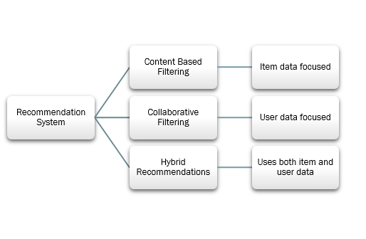

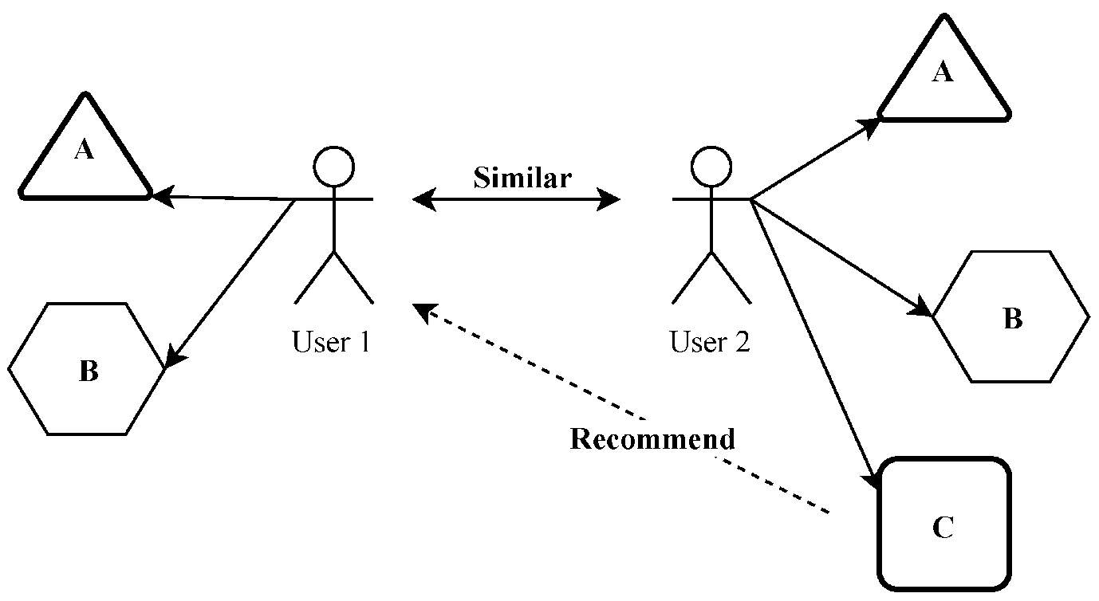

**4.2. INPUT DESIGN**

Once the output requirements have been finalized, the next step is to find out what data need to be made available to the system to produce the desired outputs. The basic documents in which these data are available need to be identified. If necessary, these documents may have to be revised or new documents may have to be introduced.

The decisions made during the input design are

* Methodology Chosen Rational Unified Process (Rup)
* Elaboration Phase
* Construction Phase

Once the analysis and design of the system has been done, it would be necessary to identify the data that are required to be processed to produce the outputs. Input is one of the most expensive phases of the operation of a computerized system and creates sometimes a major problem. Different type of problem with a system can usually be traced back to faulty input design method needless to say, therefore, that the input data are the lifeblood of a system and have to be analyzed and designed with utmost care and consideration. Input design features can ensure the reliability of the system and generate correct reports form the accurate data. The input design also determines whether the user can interact efficiently with the system.

Input data of a system may not be necessarily is raw data captured in the system from scratch. These can also be the output of another system or subsystem. The design of input covers all phases of input from the creation of initial data to actual entering the data to the system for processing. The design of input involves identifying the data needed, specifying the characteristics of each data item, capturing & preparing data for computer processing and ensuring correctness of data.

**4.3. OUTPUT DESIGN**

Output Design generally refers to the result and information that are generated by the system for many end-users, output is the main reason for developing the system and the basis on which they evaluate the usefulness of the application. The starting point of the design process is the proper knowledge of system requirements which will normally be converted in terms of output.

Presenting the data processed by a computer-based information system in an attractive and usable form has become very essential these days’ success and acceptance of a system to some extent depends on good presentation. Therefore, system analyst must know fully how to design output report in an attractive way. Many new output devices are being introduced in the market because of recent development in computer technology. System analyst must be aware of these new technologies and try to use these new output devices if possible. Currently, excellent graphic displays are widely available. Speech output systems are also fast emerging.

**4.4. CSV DATASETS**

**CSV FILE NAME :** MOVIE, CREDIT

**PURPOSE :** ANALYSIS DATASETS AND RECOMMENDING

|  |  |  |  |
| --- | --- | --- | --- |
| * + - 1. **FIELDS** | * + - 1. **DATA TYPE** | * + - 1. **CONSTRAINS** | * + - 1. **DESCRIPTION** |
| * + - 1. S.NO | * + - 1. Number | * + - 1. Data Roll No | * + - 1. Stored Roll NO |
| * + - 1. Movie Name | * + - 1. General | * + - 1. String | * + - 1. Stored Movie names |
| * + - 1. Movie genre | * + - 1. General | * + - 1. String | * + - 1. Stored Types |
| * + - 1. Movie Rating | * + - 1. Number | * + - 1. Some Full Value | * + - 1. Stored a User Review |

**4.5. SYSTEM DEVELOPMENT**

The objectives of this maintenance work are to make sure that the system gets into work all time without any bug. Provision must be for environmental changes which may affect the computer or software system. This is called the maintenance of the system. Nowadays there is the rapid changes in the software world. Due to this rapid change the system should we capable of adapting these changes .in our project the process can be added without affecting other parts of the system

Development stage plays a vital role the system liable to accept the any modification after its implementation. This system has been designed to favor all new changes. Doing this will not affect the system performance or its accuracy, the procedure level testing is made first. by given improper inputs the errors occurred are noted and eliminated the web from level testing is made, for example storage of data to the table in the correct manner. Existing system and its constraints on implementation, designing of methods to achieve changeover and evaluation of changeover methods

Development is the process of converting a new system design into operations it is the has that focuses on user training site preparation and file conversation for installing a candidate system the important factor that should be considered as here is that the conversion should not disrupt the following of the organization.

**4.6. MODULE DESCRIPTIONS**

The model used for this project is the Waterfall model of software development. This model follows a sequential order which ensures that a phase is completed before another phase begins. This system model emphasizes planning in early stages, is used in projects where all the system requirements are known and in addition, its intensive documentation and planning make it work well for projects in which quality control is a major concern.

SYSTEM TESTING AND IMPLEMENTATION

**5. SYSTEM TESTING AND IMPLEMENTATION**

**5.1. SYSTEM TESTING**

**5.1.1 TESTING METHODOLOGIES**

A strategy for software testing must accommodate low-level tests that are necessary to verify that a small source code segment has been correctly implemented as well as high-level tests that validate major system functions against customer requirements. A strategy must provide guidance for the practitioner and a set of milestones for the manager. Because the steps of the test strategy occur at a time when deadline pressure begins to rise, progress must be measurable and problems must surface as early as possible. Following testing techniques are well known and the same strategy is adopted during this project testing.

**5.2 SYSTEM IMPLEMENTATION**

When the initial design was done for the system, the client was consulted for the acceptance of the design so that further proceedings of the system development can be carried on. After the development of the system a demonstration was given to them about the working of the system. The aim of the system illustration was to identify any malfunction of the system. After the management of the system was approved the system implemented in the concern, initially the system was run parallel with existing manual system.

CONCLUSION

**6. CONCLUSION**

With the theoretical inclination of our syllabus, it becomes very essential to take the utmost advantage of any opportunity of gaining practical experience that comes along. The construction of this Minor Project **“Movie Recommendation System**” was one of these opportunities. It gave us the requisite practical knowledge to supplement the already taught theoretical concepts thus making us more competent as a computer engineer.

**The project from a personal point of view also helped us in understanding the following aspects of project development:**

* The planning that goes into implementing a project.
* The importance of proper planning and an organized methodology.
* The key element of team spirit and co-ordination in a successful project

SCOPE FOR FUTURE STUDY

**7. SCOPE FOR FUTURE STUDY**

The project has a very vast scope in future. The project can be implemented on intranet in future. Project can be updated in near future as and when requirement for the same arises, as it is very flexible in terms of expansion. With the proposed software of database Space Manager ready and fully functional the client is now able to manage and hence run the entire work in a much better, accurate and error free manner. The following are the future scope for the project.

* In future can we use this website on our mobile phones.
* We collecting recommendation value in very perfect.
* We are use more algorithms to get good result.

BIBLIOGRAPHY

**8.** **BIBLIOGRAPHY**

**TEXT BOOK REFERENCES**

1. HTML & CSS: The Complete Reference, Fifth Edition, Book by Thomas Powell.
2. HTML and CSS: Visual Quick start Guide, Book by Bruce Hyslop and Elizabeth Castro.
3. HTML5 and CSS3 All-in-One For Dummies. Book by Andy Harris.
4. Web design, Book by Thomas Powell.
5. Python Basics and Oops.
6. Python Machine Learning advanced concepts.

**WEBSITES REFERENCE**

1. [Https://www.w3schools.com/html/](https://www.w3schools.com/html/)
2. <https://www.w3schools.com/css/>
3. <https://www.w3schools.com/js/>
4. http//:[www.geeksforgeeks.org/python-implementation-of-movie recommender-system/](http://www.geeksforgeeks.org/python-implementation-of-movie%20recommender-system/)
5. <https://www.tutorialspoint.com/html/index.htm>
6. <https://www.tutorialspoint.com/css/index.htm>
7. <https://www.tutorialspoint.com/javascript/index.htm>
8. [Recommendation Systems - Demographic Filtering (Part 1) | Home (rahuls0959.github.io)](https://rahuls0959.github.io/ds-blog/python/recommendation%20system/relevancy/collaborative%20filtering/content-based%20filtering/demographic%20filtering/2020/06/06/_Recommendation-System_Part-1.html)
9. [Build A Movie Recommendation System on Your Own (analyticsvidhya.com)](https://www.analyticsvidhya.com/blog/2020/11/create-your-own-movie-movie-recommendation-system/)

**A. SOURCE CODE**

**Index.html**

<!DOCTYPE html>

<html lang="en" >

<head>

  <meta charset="UTF-8">

  <title>Movie Recommender - Manikandan </title>

    <meta name="viewport" content="width=device-width, initial-scale=1.0">

  <link rel="stylesheet" href="https://cdnjs.cloudflare.com/ajax/libs/normalize/5.0.0/normalize.min.css">

<link rel='stylesheet' href='https://fonts.googleapis.com/css?family=Poppins:300,500&amp;display=swap'>

<!--  Css style -->

<style>

html {

  box-sizing: border-box;

}

*,

*:before,

*:after {

  box-sizing: inherit;

}

body {

  font-family: "Poppins", sans-serif;

  font-weight: 300;

  font-size: 100%;

  background-color: #B6F3E4;

  line-height: 1.5;

  color: #000;

}

a {

  text-decoration: none;

}

ul {

  margin: 0;

  padding: 0;

  list-style-type: none;

}

figure {

  max-width: 100%;

  height: auto;

  margin: 0;

}

.js-overflow {

  overflow: hidden;

}

.bg-white {

  background-color: #fff;

}

.bg-black {

  background-color: #000;

}

.absolute-bg {

  position: absolute;

  top: 0;

  left: 0;

  z-index: 0;

  height: 100%;

  width: 100%;

  background-position: 50%;

  background-repeat: no-repeat;

  background-size: cover;

}

    .movie{

        height: 70vh;

        margin-top: 15vh;

        margin-bottom: 15vh;

        margin-right: 5vh;

        margin-left: 5vh;

        display: block;

        background-color: white;

        border-radius: 20px;

        padding: 1em;

        width: auto;

        box-shadow: 0px 0px 10px -4px grey;

        text-align: center;

    }

    #movie_name{

        width: 70%;

        padding: 1em;

        border-radius: 5px;

        text-align: center;

        border: 1px solid grey;

    }

    #submission_button{

        width: 25%;

        padding: 1em;

        margin: 1em;

        border-radius: 5px;

        color: white;

        background-color:dodgerblue;

        border-style: none;

    }

    @media screen and (max-width:600px) {

        .movie{

            margin-top: 12vh;

            margin-bottom: 12vh;

        }

}

</style>

</head>

<body style="background-image: url('https://www.bing.com/th?id=OIP.qhv-5zDAjwxcbZkKuezBsgHaEK&w=265&h=165&c=8&rs=1&qlt=90&o=6&pid=3.1&rm=2');">

<!-- partial:index.partial.html -->

<!-- Demo -->

<div class="movie">

        <h2><u>Movie Recommendation System</u></h2>

        <form action="{{ url_for('main') }}" method="POST">

            <input type="text" id="movie_name" name="movie_name" placeholder="Enter a full movie name" required />

            <input type="submit" id="submission_button" value="Submit"/>

        </form>

        <p style="color: #919191; padding: 1em;">The model uses <b>Content Based Recommendations</b> to find similar movies. Intuitive idea behind is <i>"If a person likes a particular item, you will also like an item that is similar to it."</i> The dataset is taken from <a href="https://www.kaggle.com/" target="_blank"  style="color: #82caff">Kaggle.com</a>.</p>

        <br>

  </div>

<!-- partial -->

  <script src='https://cdn.jsdelivr.net/npm/jquery@2.2.4/dist/jquery.min.js'></script>

<script src='https://cdn.jsdelivr.net/npm/animejs@3.1.0/lib/anime.min.js'></script>

<script>

// Menu

// Inits

$(() => {

  // Spanize

  const span = $('.js-span');

  let $ele, words;

  for (let i = 0; i < span.length; i++) {

    $ele = $(span).eq(i);

    words = $ele.html();

    $ele.html(words.replace(/([A-z0-9'@+-<>.,'"“”‘’?!*&/]+)/g, '<span>$&</span>'));

  }

  Menu.init();

});

</script>

</body>

</html>

**positive.html**

<!DOCTYPE html>

<html lang="en" >

<head>

  <meta charset="UTF-8">

  <title>Movie Recommender - Manikandan</title>

    <meta name="viewport" content="width=device-width, initial-scale=1.0">

  <link rel="stylesheet" href="https://cdnjs.cloudflare.com/ajax/libs/normalize/5.0.0/normalize.min.css">

<link rel='stylesheet' href='https://fonts.googleapis.com/css?family=Poppins:300,500&amp;display=swap'>

    <script src="https://kit.fontawesome.com/a076d05399.js"></script>

<style>

html {

  box-sizing: border-box;

}

*,

*:before,

*:after {

  box-sizing: inherit;

}

a {

  text-decoration: none;

}

      s.hamburger.on('click', () => {

        Menu.toggleMenu(menuContainerWidth);

      });

      s.body.on('keyup', e => {

        if (s.body.hasClass(s.open) && e.which === 27) {

          Menu.toggleMenu(menuContainerWidth);

        }

      });

    },

    toggleMenu(width) {

      s.hamburger.toggleClass('js-hamburger');

      s.body.toggleClass(s.open);

      s.body.toggleClass(s.overflow);

      // Opening transition

      if (s.body.hasClass(s.open)) {

        s.prevWidth = width;

        anime.timeline({

          easing: 'easeOutQuart',

          duration: 600,

          begin() {

            $('.menu__img').css('left', `${width}%`);

            s.body.addClass(s.visible);

          } }).

        add({

          targets: '.menu__container',

          width: [0, `${width}%`] }).

        add({

          targets: '.menu__img',

          width: [0, `${100 - width}%`] },

        0);

      }

      // Closing transition

      if (!s.body.hasClass(s.open)) {

        anime.timeline({

          easing: 'easeInQuart',

          duration: 600,

          delay: 200,

          complete() {

            s.body.removeClass(s.visible);

          } }).

        add({

          targets: '.menu__container',

          width: [`${s.prevWidth}%`, 0] }).

        add({

          targets: '.menu__img',

          width: [`${100 - s.prevWidth}%`, 0] },

        0);

      }

    } };

})();

// Inits

$(() => {

  // Spanize

  const span = $('.js-span');

  let $ele, words;

  for (let i = 0; i < span.length; i++) {

    $ele = $(span).eq(i);

    words = $ele.html();

    $ele.html(words.replace(/([A-z0-9'@+-<>.,'"“”‘’?!*&/]+)/g, '<span>$&</span>'));

  }

  Menu.init();

});

</script>

</body>

</html>

**app.py**

import flask

#import difflib

import pandas as pd

from sklearn.feature_extraction.text import CountVectorizer

from sklearn.metrics.pairwise import cosine_similarity

app = flask.Flask(__name__, template_folder='templates')

df2 = pd.read_csv('./model/tmdb.csv')

count = CountVectorizer(stop_words='english')

count_matrix = count.fit_transform(df2['soup'])

cosine_sim2 = cosine_similarity(count_matrix, count_matrix)

df2 = df2.reset_index()

indices = pd.Series(df2.index, index=df2['title'])

all_titles = [df2['title'][i] for i in range(len(df2['title']))]

def get_recommendations(title):

    cosine_sim = cosine_similarity(count_matrix, count_matrix)

    idx = indices[title]

    sim_scores = list(enumerate(cosine_sim[idx]))

    sim_scores = sorted(sim_scores, key=lambda x: x[1], reverse=True)

    sim_scores = sim_scores[1:11]

    movie_indices = [i[0] for i in sim_scores]

    tit = df2['title'].iloc[movie_indices]

    dat = df2['release_date'].iloc[movie_indices]

    return_df = pd.DataFrame(columns=['Title', 'Year'])

    return_df['Title'] = tit

    return_df['Year'] = dat

    return return_df

# Set up the main route

@app.route('/', methods=['GET', 'POST'])

def main():

    if flask.request.method == 'GET':

        return (flask.render_template('index.html'))

    if flask.request.method == 'POST':

        m_name = flask.request.form['movie_name']

        m_name = m_name.title()

        #        check = difflib.get_close_matches(m_name,all_titles,cutout=0.50,n=1)

        if m_name not in all_titles:

            return (flask.render_template('negative.html', name=m_name))

        else:

            result_final = get_recommendations(m_name)

            names = []

            dates = []

            for i in range(len(result_final)):

                names.append(result_final.iloc[i][0])

                dates.append(result_final.iloc[i][1])

            return flask.render_template('positive.html', movie_names=names, movie_date=dates, search_name=m_name)

if __name__ == '__main__':

    app.run()

**B. SCREEN SHOTS**

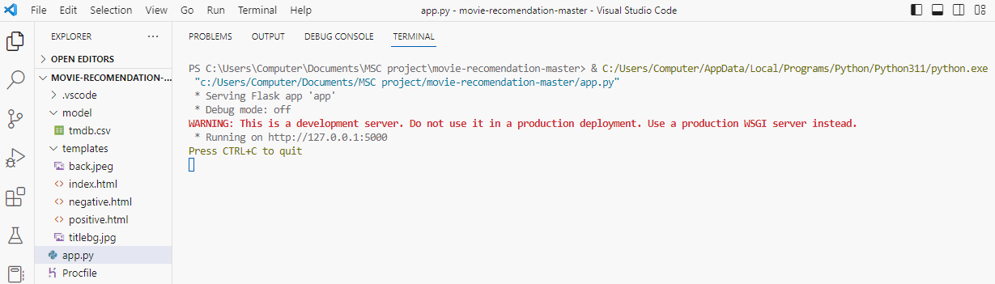

1. 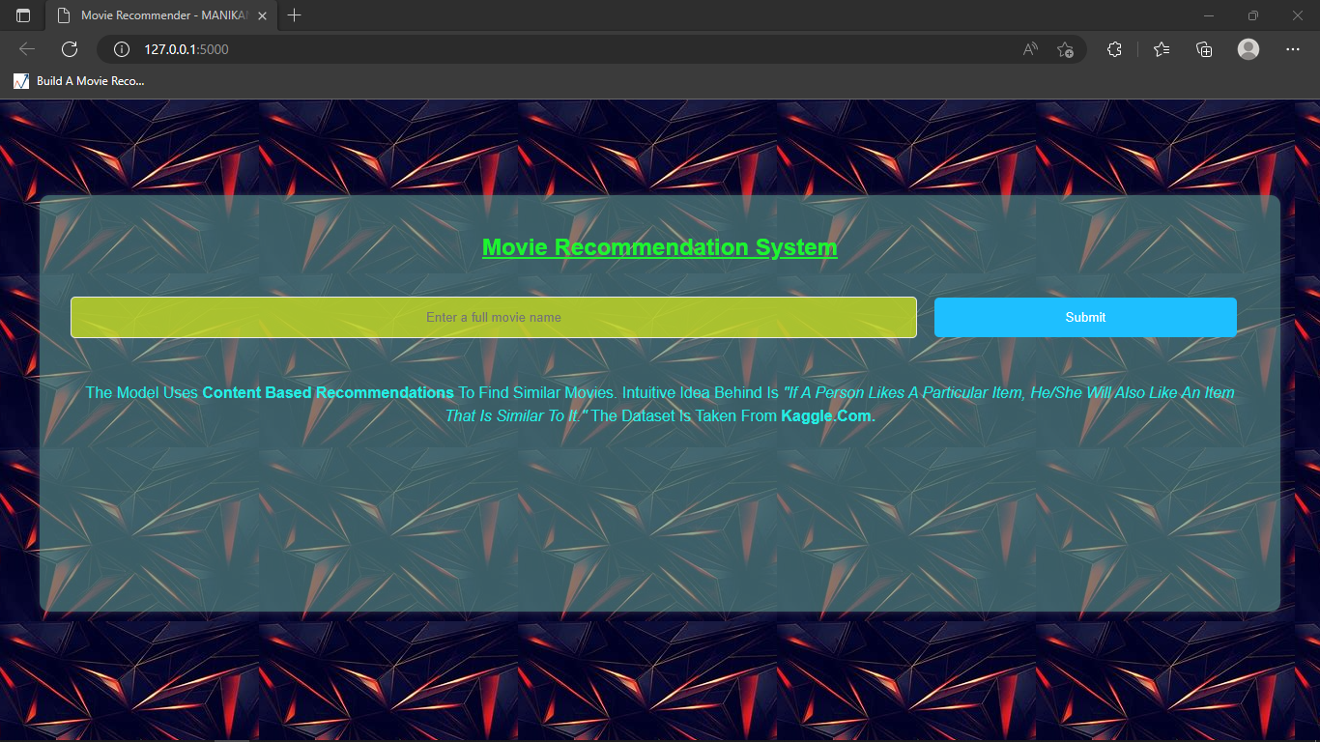**Vs code output link show screen.**
2. **First Page Web site.**

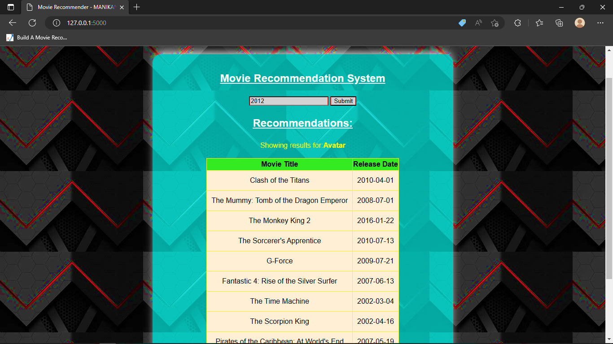

1. **Result showing screen**